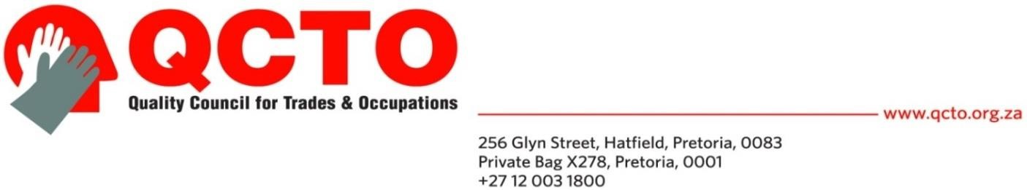

Qualifications/Part-Qualifications/Skills Programmes Development Schedule

1. Occupation/specialisations detail
Occupation OFO Code Specialisation Anticipated date of completion of qualification development process
…

2. Quality Partner information

QUALITY PARTNER DETAILS

NAME OF QUALITY PARTNER | …
ADDRESS | …
WEBSITE | …

3. Subject Matter Expert (SME) facilitating the development of a qualification and or part qualification
The following person is/will be contracted by the Quality Partner to facilitate the development of an occupational qualifications and or part qualifications:

APPOINTED SUBJECT MATTER EXPERT (SME) DETAILS

NAME AND SURNAME | …
IDENTITY NUMBER | …
ADDRESS | …
EMAIL ADDRESS | …
CELL NUMBER
SIGNATURE OF SME | …
DATE | …

4. Qualification Development Planned Time Lines

Activities due date:

  - 1. Establish a database of expert practitioners (people qualified in that occupation and can include assessors, educationalists, work place practitioners etc) or determine a process of linking various databases to obtain nominations for working group members
…
  - 2. First 2 / 3 day working group meeting of expert practitioners to develop occupational profiles and points of external assessment.
…
  - 3. Send out occupational profile and points of external assessment with recommended AQP for each, for verification to all identified expert practitioners (narrow consultation)
…
  - 4. Prepare progress report on process and inputs received on the occupational profile and how it was dealt with and submit to QCTO (including participation list)
…
  - 5. Arrange working group meetings of expert practitioners (work place practitioners) to develop the work experience module specifications (including the statement of work experience)
…
  - 6. Arrange working group meetings of expert practitioners to develop the practical skills module specifications (including internal assessment guidelines)
…
  - 7. Arrange working group meeting of educationalists to develop
  - the subject specifications (including internal assessment specifications)
…
  - 8. Send out occupational curriculum for verification to all identified constituencies (broader consultation)
…
  - 9. Prepare report on process and inputs received and how it was dealt with and submit to QCTO (including participation list)
…
  - 10. Arrange working group meeting of expert practitioners and assessment quality partner representatives to develop the assessment specifications for the external assessment of the qualifications and or part qualifications
…
  - 11. Capture curriculum and assessment specifications, verify correctness of information and qualification details and submit to QCTO
…
  - 12. Prepare the qualification process report and submit to QCTO
…
  - 13. Prepare a development close out report to the QCTO on: · Challenges experienced · Actual qualification development facilitator costs · Logistical costs · Administration costs · Verification costs
…

5. Quality Partner Officer Details

RESPONSIBLE OFFICIAL DETAILS

NAME AND SURNAME | …
DESIGNATION | …
EMAIL ADDRESS | …
CELL NUMBER
SIGNATURE OF OFFICIAL | …
DATE | …

